EXPERIMENT – 5

Prioritization of Library Management System Requirements Using MoSCoW Method

AIM
To analyze and categorize the requirements of a Library Management System using the MoSCoW prioritization method based on user impact, stakeholder needs, feasibility, time, budget, and available resources.

SOFTWARE REQUIRED
- Google Sheets / Microsoft Excel
- Web Browser
- Internet Connection

PROCEDURE
Step 1: Identify Requirements
- Analyze the given Library Management System requirements.
- Identify all ten functional requirements.
- Understand their importance to users, librarians, and administrators.
Step 2: Understand the MoSCoW Method
The MoSCoW method divides requirements into four categories:
Category | Description
Must-Have | Essential features required for the system.
Should-Have | Important features that can be implemented after core requirements.
Could-Have | Optional features that improve user experience.
Won't-Have | Features excluded from the current release due to constraints.
Step 3: Create an Excel Sheet
- Open Microsoft Excel or Google Sheets.
- Create a new spreadsheet.
- Add the following column headings: S.No, Requirement, MoSCoW Category, User/Stakeholder Impact, Feasibility, and Justification.
- Enter all ten requirements.
Step 4: Categorize the Requirements
Prioritize the requirements based on their importance and feasibility, assuming limited resources for the initial release.

REQUIREMENT PRIORITIZATION TABLE
S.No | Requirement | Category | Justification
1 | Search books by title and author | Must-Have | Essential for finding books easily.
2 | Online book reservation system | Must-Have | Enables users to reserve books remotely.
3 | Monthly borrowed-books reports | Should-Have | Helps administrators monitor library activities.
4 | Email notifications for overdue books | Should-Have | Reduces late returns and improves communication.
5 | QR code scanning | Could-Have | Speeds up borrowing and returning books.
6 | User-friendly librarian dashboard | Must-Have | Essential for managing daily library operations.
7 | Book reviews and ratings | Could-Have | Improves user engagement.
8 | Chatbot assistance | Won't-Have | Requires additional development resources.
9 | Mobile application | Won't-Have | Requires additional time, budget, and testing.
10 | Multi-language support | Could-Have | Improves accessibility for different users.
Step 5: Format and Save the Spreadsheet
- Highlight the column headings.
- Apply different colors to distinguish the four MoSCoW categories.
- Adjust the column widths and text alignment.
- Verify the categorization and justification.

Output
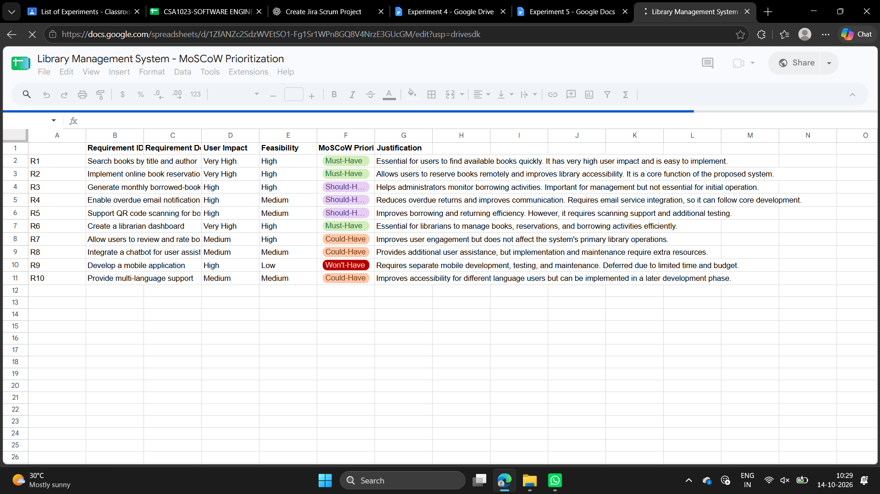

RESULT
The ten requirements of the Library Management System were successfully analyzed and categorized using the MoSCoW prioritization method. The completed Excel spreadsheet contains all requirements along with their priorities and justifications.

OUTCOME
Through this experiment, we gained practical knowledge of requirement prioritization using the MoSCoW method. We learned how to identify essential and optional features, evaluate stakeholder needs, and prioritize software requirements based on available time, budget, and resources. This experiment helped us understand effective requirement management in software development.

